LOT DID NOT LISTEN TO GOD!
Genesis 18-19

MAIN POINT: God loves us and wants the absolute best for us. We can trust God and make the right choice. It is very important to obey God all the time.

KEY VERSE: “So when God destroyed the cities of the valley, He showed concern for Abraham. He brought Lot out safely when He destroyed the cities where Lot had lived.” Genesis 19:29

Craft Ideas

“Lot Did Not Listen to God” Hand Picture

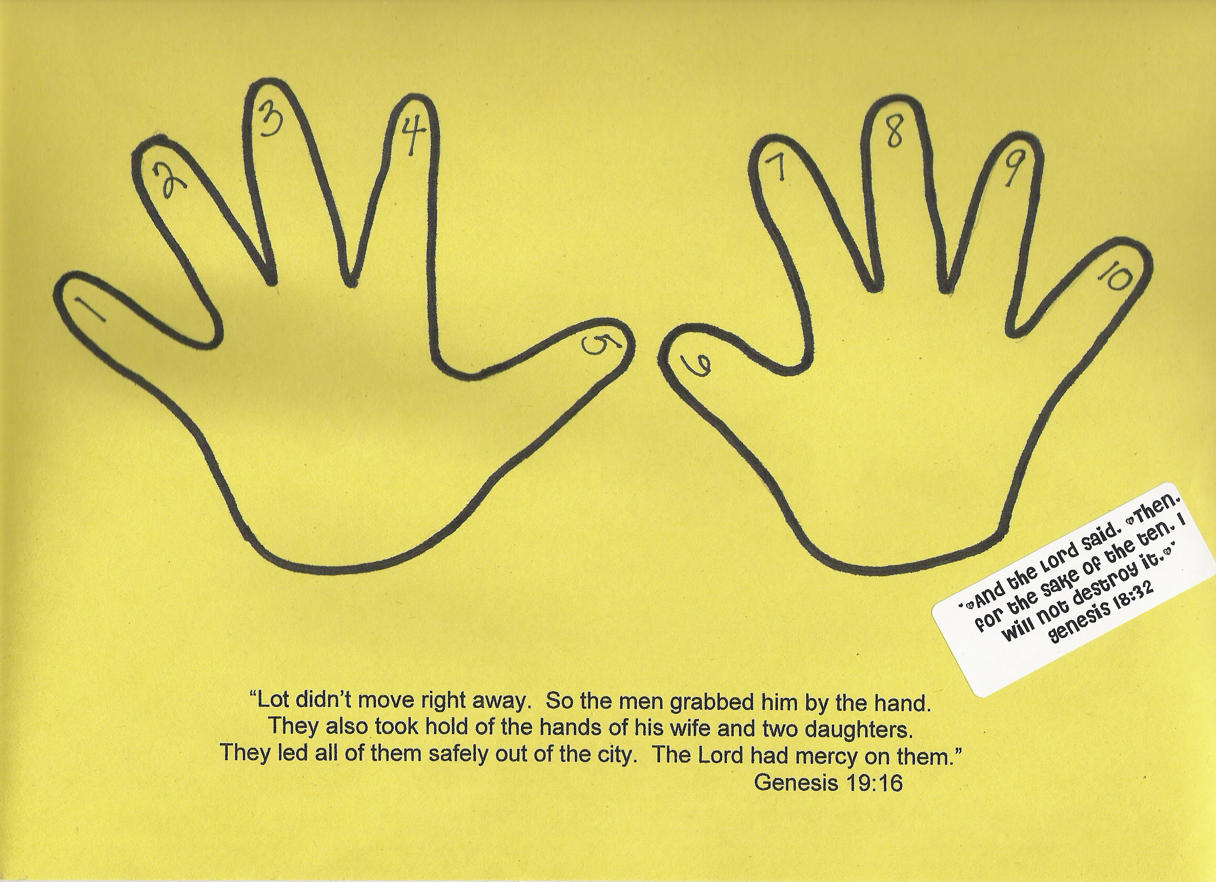

Craft Supplies: Cardstock paper, any color, address labels, Avery #5160.

- Copy Genesis 19:16 onto cardstock. Print on landscape, loading the paper in the bypass tray of your copier.
- Print Genesis 18:32 onto address label.
- Draw around each child’s hands. Label each finger 1-10.
- Add prepared stickers to picture.

“I Will Trust God” Bracelets
Blank Slap Bracelets, www.orientaltrading.com, 57-6532

- Print “I will Trust God” on front of slap bracelet, using colored permanent markers.
- Decorate remainder of front of bracelet, using permanent colored markers.
- Print Key Verse onto sticker address labels, Avery #5167 and apply to back of bracelet.

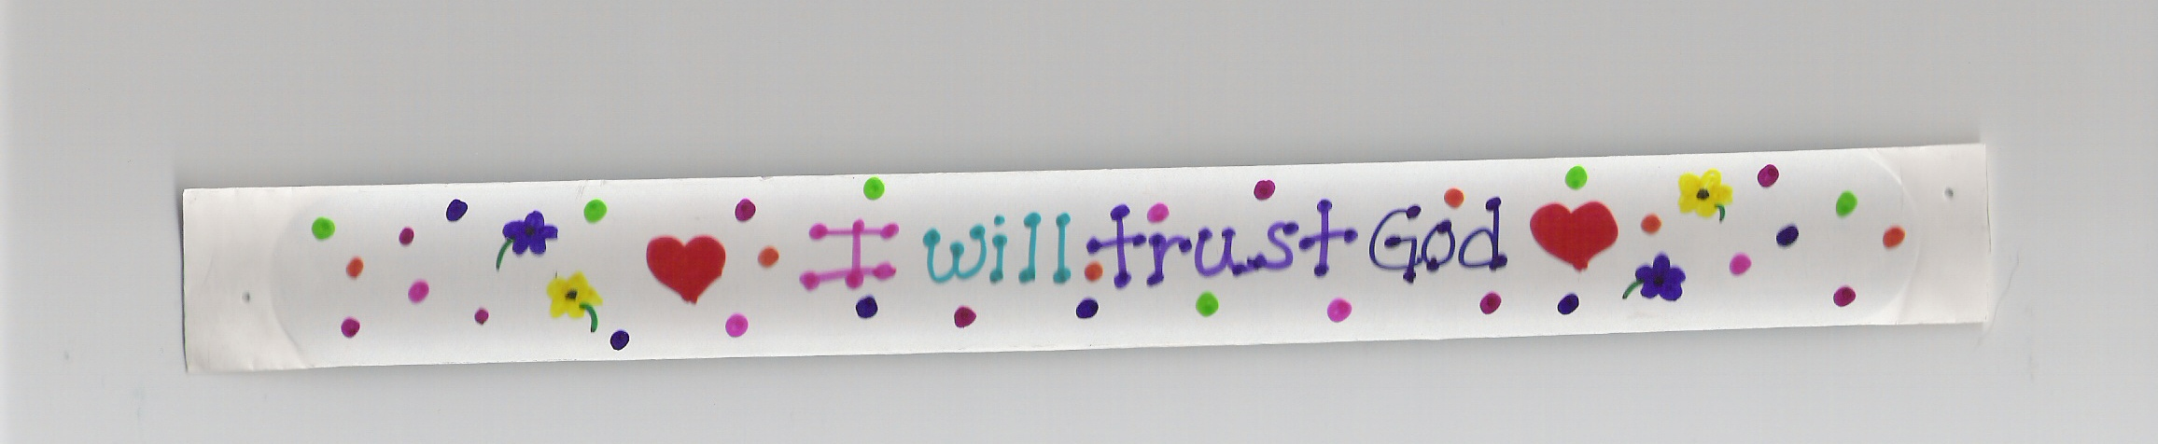

“I Can Trust God” buttons
Design Your Own Button, www.orientaltrading.com, 57/9028
- Write “I Will Trust God” on button insert.
- Decorate with colored markers and stickers.
- Apply Key Verse sticker to back of insert.
- Snap button back together and wear home!

